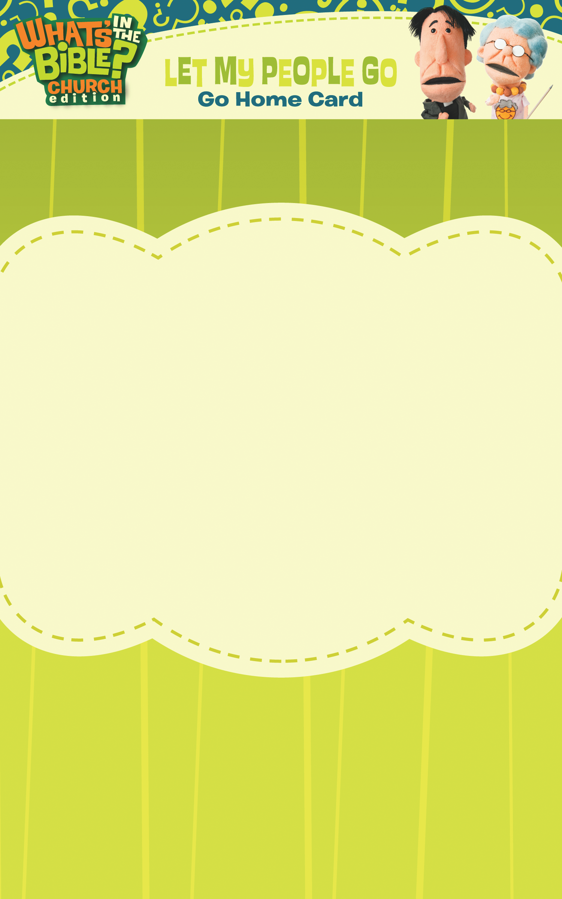
- What food did God rain down from heaven on the Israelites? (Manna)

- What was the tent called that the Israelites built for God? (Tabernacle)

- What false god did the Israelites build while Moses was on Mt. Sinai? (A Golden Cow)

- Would you have liked to have been the priest that went into the Room of the Most High? Discuss why or why not.

- How many commandments are there? (10)

Today your child learned about Moses and the Israelites from the book of Exodus. Here are a few discussion questions for the way home:

Go to www.whatsinthebible.com/thebigquestion with a parent and answer the BIG question. Click on DVD 2, Week 4.

Can you finish this sentence? The room in the tabernacle where _____ resided was called the ____ ____ _____.

Parent Signature: _____________________________________
DVD 2: Week 4
Today your child learned about Moses and the Israelites from the book of Exodus. Here are a few discussion questions for the way home:

- What food did God rain down from heaven on the Israelites? (Manna)

- What was the tent called that the Israelites built for God? (Tabernacle)

- What false god did the Israelites build while Moses was on Mt. Sinai? (A Golden Cow)

- Would you have liked to have been the priest that went into the Room of the Most High? Discuss why or why not.

- How many commandments are there? (10)

Go to www.whatsinthebible.com/thebigquestion with a parent and answer the BIG question. Click on DVD 2, Week 4.

Can you finish this sentence? The room in the tabernacle where _____ resided was called the ____ ____ _____.

Parent Signature: _____________________________________
DVD 2: Week 4

